Assignment-1 Theory only
- Install Python (latest version) and VS Code on your computer, then take a screenshot of both the Python installation confirmation and the VS Code welcome
screen.
Ans. Python installation confirmation
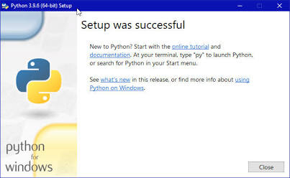

VS Code welcome screen 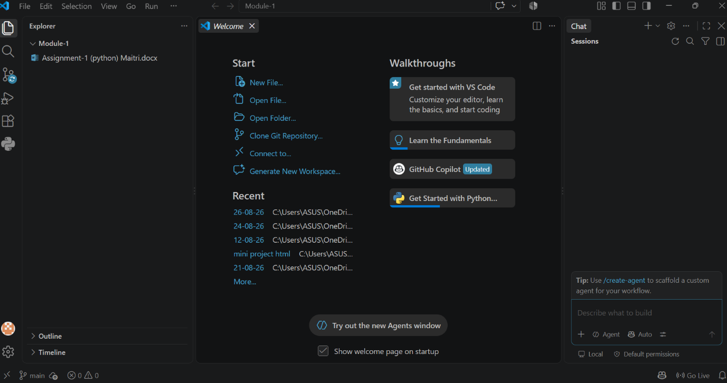

- Explain the difference between how Python executes code versus how C or Java executes code, using your own words and a simple example for each.
Ans.
C: c_code.c $→$ Compile $→$ app.exe $→$ Run
Example:-
#include <stdio. me>
int main() {
printf("Hello, World!\n");
return 0;
}
Python: python_code.py $→$ Run directly line by line
Example:- print("Hello World!")

Java: java_code.java $→$ Compile $→$ bytecode.class $→$ Run on JVM
Example:-
public class Hello {
public static void main(String[] args) {
System.out.println("Hello, World!");
}
}

